INS3121
December 29, 2017

SOIL MECHANICS
Group 4: Assoc . Prof. Dr. Pelin Özener
Group 5: Asst. Prof. Dr. Nejat N. Çetinkaya
MAKE UP EXAM
Q.1 | Q.2 | Q.3 | Q.4 | Q.5 | TOTAL
Name and Surname:
Number:
Group:

- i. A soil profile which has a water content (w) of 25% and a specific gravity (Gs) of 2.67 consists of cohesive soil layer with a height of 18m and groundwater table locates on the soil surface. Calculate the total stress, effective stress and pore pressure at 9 m depth.
ii. A sieve analysis was performed on the cohesive soil and percentage passing #200 sieve was found to be 70%. In addition to this, liquid limit and plastic limit tests were performed on the soil sample passing #40 sieve in order to determine index properties of the soil and found to be w_{L} = %58, w_{P} = %38, respectively. Classify the soil according to Unified Soil Classification System (USCS) and American Association of State Highway and Transportation Officials (AASHTO) Classification System.

- The flow-net for the water seepage below a sheet pile wall is given below. The hydraulic conductivity (permeability) of the soil is determined to be k=4.8x10⁻⁶ cm/sec. According to the given information,
- Calculate the amount of water seepage under the sheet pile wall.
- Calculate the total hydraulic head and water pressure at points A, B, and, C.

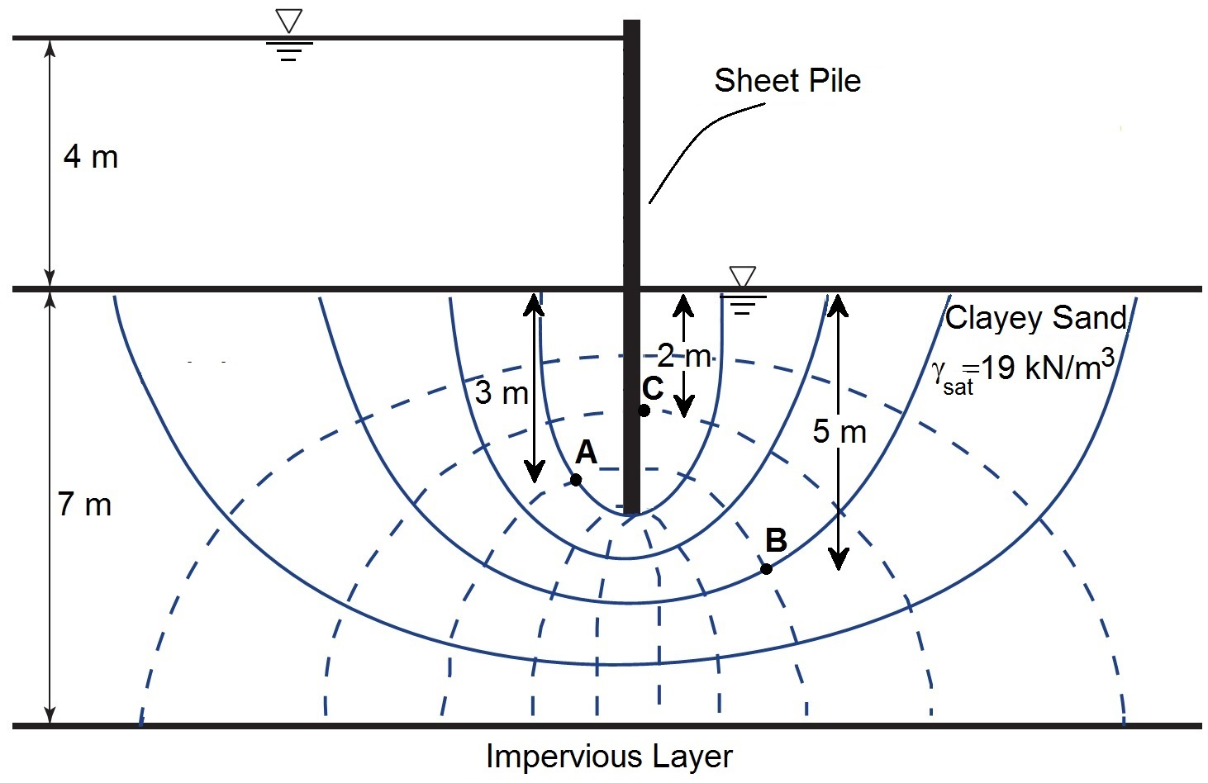
- A raft foundation will be constructed on the soil profile a depth of 3.0 m below from the ground surface as shown in the figure. Dimensions of the raft foundation is 20 m x 20 m in both direction and the stress that will be du to superstracture load is computed to be q=200 kPa.
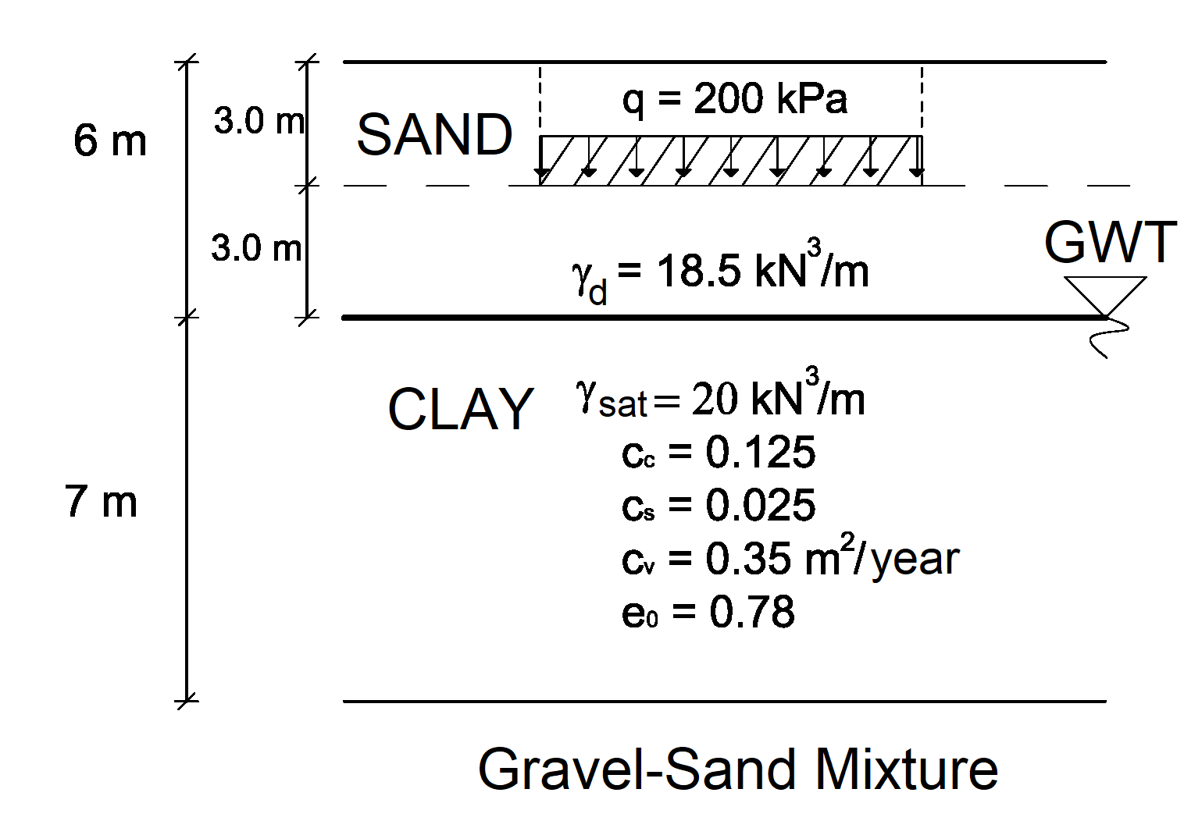
a) Compute the settlement that will take place underneath the center of the raft foundation due to primary consolidation of the normally consolidated clay layer (Determine the pressure increment in the clay layer with simplified method due to uniform loading)
b) Compute the settlement that will take place after 10 years.
U (%) | 10 | 20 | 30 | 40 | 50 | 60 | 70 | 80 | 90
T_{v} | 0.008 | 0.031 | 0.071 | 0.126 | 0.197 | 0.287 | 0.408 | 0.567 | 0.848

- A series of triaxial tests were carried out on undisturbed over consolidated clay samples and the test results are as follows:

Test | Cell Pressure (kPa) | Deviatoric Stress (kPa)
1.CD Test | 120 | 190
2.CD Test | 240 | 360

a) Find the drained shear strength parameters of the clay soil.
b) Compute the angle that failure plane makes with respect to horizontal (α_{f}).
c) Draw the Mohr Circle for the tests and the failure envelope for the clay soil.

- The soil samples which have a void ratio of 0.82 were recovered from the silty clay soil and max. unit weight (γ_{kmaks}), optimum water content (w_{opt}) and specific gravity of the soil samples were found to be 18.5 kN/m³, 13%, and 2.65, respectively at the end of the Standard Proctor and pycnometer tests conducted in the laboratory.
- Calculate how much excavated soil is necessary to construct a compacted fill of 10000 m³ assuming relative compaction of 95%.
- If the compacted fill will be constructed at optimum water content, compute the volume of the water in the compacated fill.

Time is 90 minutes. Good Luck…

